HealthGPS Codebase Breakdown

Contents

Core Codebase Breakdown- 2
1. Core Components (HealthGPS.Core/) 2
2. Main Simulation (HealthGPS/) 3
3. Input Handling (HealthGPS.Input/) 3
4. Console Interface (HealthGPS.Console/) 3
KEY FUNCTION FLOWS- 4
Main Program flow- 4
Complete Flow of the HealthGPS Codebase- 5
Basic Entity Structure- 5
Main Components and their Relationship- 6
1. Person (The Individual)- 6
2. Population (Collection of Persons)- 6
3. Disease (Health Condition)- 6
Key Functions and their Usage- 6
1. Population Management- 6
2. Health Status Update- 7
3. Simulation Control- 7
Mathematical Models Used- 7
1. Kevin Hall Energy Balance Model- 7
2. Static Linear Model 7
3. Model Interactions and Flow- 8
4. Other Mathematical Relationships 8
Performance Considerations 9
Performance Critical Sections 10
Memory Intensive Operations 10
Parallel Processing Hotspots 11
I/O Intensive Operations 11
Potentially Redundant or Unused Components 11
Performance Recommendations 13

The main subdirectories.
- Src
- External
- HealthGPS
- HealthGPS.Tests
- HealthGPS.Core
- HealthGPS.Console
- HealthGPS.Input
- CMakeLists.txt

Each major component of the core functionality:
- src/HealthGPS.Core 34 sub-codebases
- src/HealthGPS 100 sub-codebases
- src/HealthGPS.Input 27 sub-codebases

- Input Data
Configuration files (JSON), Population data (CSV), Disease models, Risk factor models
- Processing
Population updates, Disease progression, Risk factor calculations, Intervention effects
- Output Data
Population statistics, Health outcomes, Intervention results
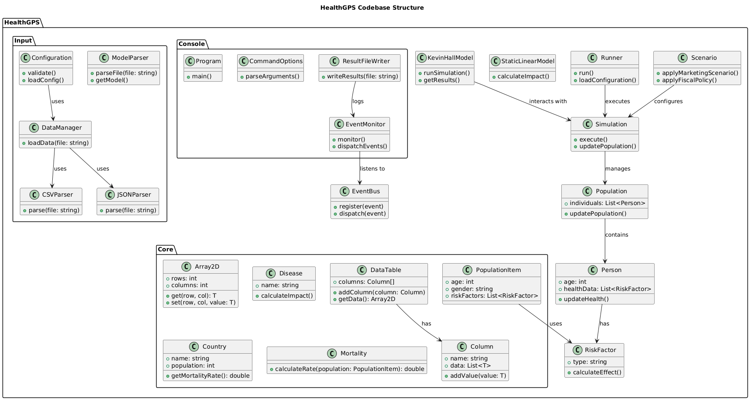

Core Codebase Breakdown-

Core Components (HealthGPS.Core/)
- Data Structures:
  - array2d.h: 2D array implementation
  - datatable.h/cpp: Table data structure for simulation data
  - column*.h: Column-based data storage implementations

- Utilities:
  - math_util.h/cpp: Mathematical utility functions
  - string_util.h/cpp: String manipulation utilities
  - thread_util.h: Threading utilities

- Domain Models:
  - disease.h: Disease modeling
  - country.h: Country-specific data
  - mortality.h: Mortality rate calculations
  - population_item.h: Population unit representation

Main Simulation (HealthGPS/)
- Models:
  - kevin_hall_model.h/cpp: Core simulation model implementation (32KB)
  - static_linear_model.h/cpp: Linear modeling components
  - risk_factor_*.h/cpp: Risk factor modelling

- Simulation Components:
  - simulation.h/cpp: Main simulation engine
  - runner.h/cpp: Simulation runner
  - population.h/cpp: Population management
  - person.h/cpp: Individual entity representation

- Scenarios:
  - marketing_scenario.h/cpp: Marketing intervention scenarios
  - fiscal_scenario.h/cpp: Fiscal policy scenarios
  - food_labelling_scenario.h/cpp: Food labeling interventions

- Event System:
  - event_*.h/cpp: Event handling and messaging system
  - event_bus.h/cpp: Event distribution system

Input Handling (HealthGPS.Input/)
- Configuration:
  - configuration.h/cpp: Configuration management
  - model_parser.h/cpp: Model definition parsing

- Data Management:
  - datamanager.h/cpp: Data access and management
  - csvparser.h/cpp: CSV file parsing
  - jsonparser.h/cpp: JSON parsing utilities

- File Handling:
  - zip_file.h/cpp: ZIP file operations
  - download_file.h/cpp: File download functionality

Console Interface (HealthGPS.Console/)
- User Interface:
  - program.cpp: Main entry point
  - command_options.h/cpp: Command-line argument handling

- Output:
  - event_monitor.h/cpp: Event monitoring and display
  - result_file_writer.h/cpp: Result output handling

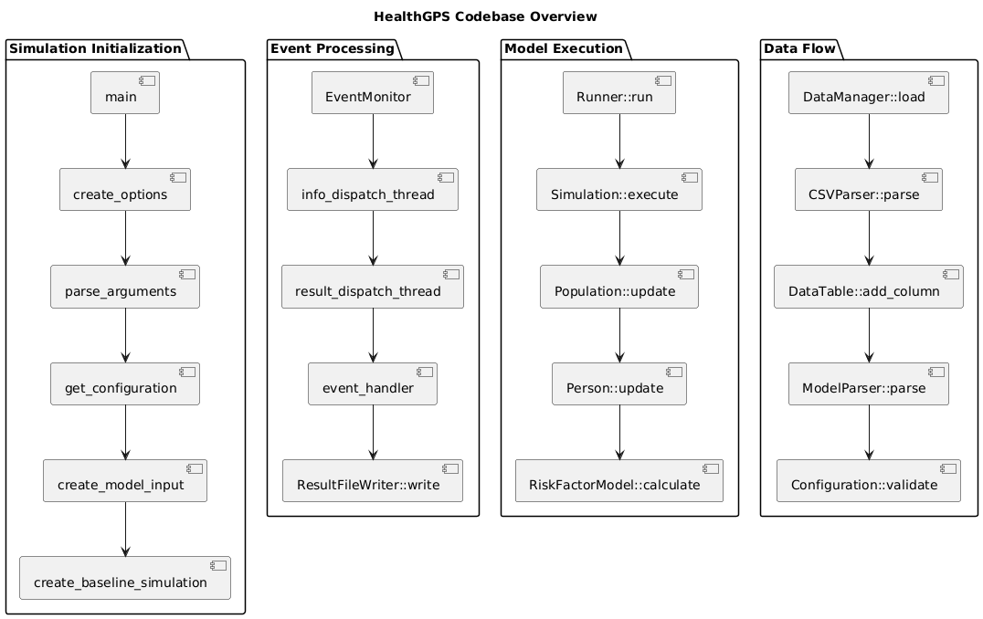
KEY FUNCTION FLOWS-

Main Program flow-
- Program startup-

main()
├─> create_options() // Setup command line options
├─> parse_arguments() // Process user inputs
├─> get_configuration() // Load configuration
└─> create_model_input() // Prepare simulation input

- Simulation Set up-
Simulation::Simulation()
├─> initialise_population() // Create initial population
├─> setup_modules() // Setup simulation modules
└─> init() // Initialize simulation

- Simulation Execution-

Runner::run()
├─> Simulation::update() // Main simulation loop
│ ├─> update_population() // Update each person
│ └─> process_events() // Handle events
└─> write_results() // Save outcomes

Complete Flow of the HealthGPS Codebase-
- program.cpp: Main entry point and simulation control ( in HealthGPS.Console)
- simulation.cpp: Core simulation engine
- kevin_hall_model.cpp: Energy balance calculations
- default_disease_model.cpp: Disease progression
- static_linear_model.cpp: Risk factor modeling
- event_monitor.cpp: Event handling
- result_file_writer.cpp: Output generation
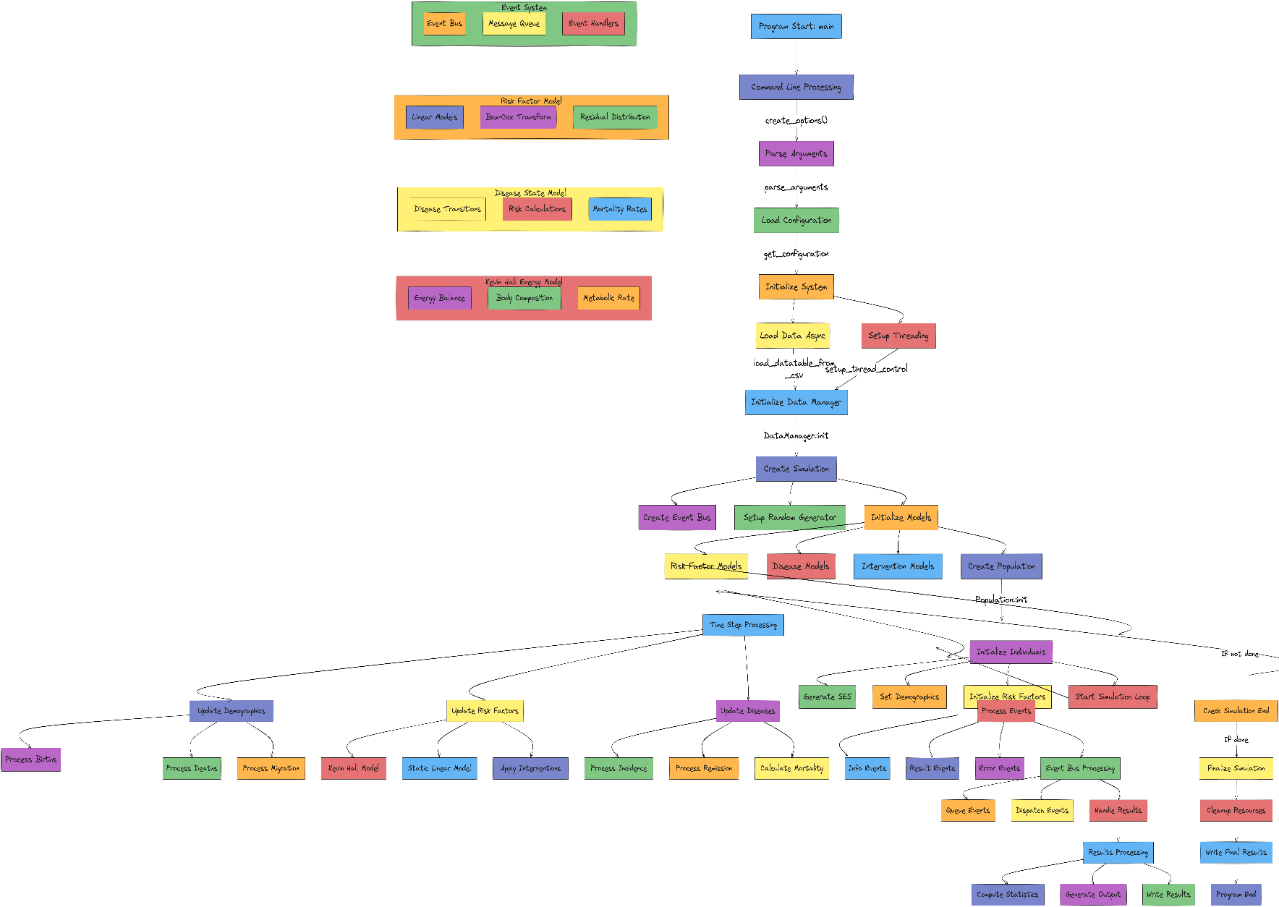

Basic Entity Structure-
A[Population] --> B[Person]
B --> C[Risk Factors]
B --> D[Diseases]
B --> E[Demographics]
E --> F[Gender]
E --> G[Age]
E --> H[Income]
E --> I[Sector]
E --> J[SES]

Main Components and their Relationship-

Person (The Individual)-

struct Person {
std::size_t id; // Unique identifier
core::Gender gender; // Male/Female
unsigned int age; // Age in years
core::Sector sector; // Urban/Rural
core::Income income; // Income category
double ses; // Socio-economic status

// Health-related data
std::map<core::Identifier, double> risk_factors;
std::map<core::Identifier, Disease> diseases;
}

Population (Collection of Persons)-

class Population {
std::vector<Person> people_; // Container of all persons
// Methods to manage population
void add(Person person, unsigned int time);
void add_newborn_babies(std::size_t number, Gender gender, unsigned int time);
}

Disease (Health Condition)-

struct Disease {
DiseaseStatus status; // free/active
int start_time; // When disease started
int time_since_onset; // Duration of disease
}

Key Functions and their Usage-

Population Management-

Population::add() // Add new person
Population::add_newborn_babies()// Add births
Person::die() // Handle death
Person::emigrate() // Handle migration

Health Status Update-

Person::get_risk_factor_value()// Get risk factors
Person::is_active() // Check if person is in simulation
Person::over_18() // Check if person is adult

Simulation Control-

Simulation::init() // Start simulation
Simulation::update() // Run simulation step
Simulation::fini() // End simulation

Mathematical Models Used-

Kevin Hall Energy Balance Model-
This is a sophisticated physiological model that simulates body weight dynamics:

Energy Balance Equations:
// Energy expenditure calculation
double EE = (K + gamma_F * F + gamma_L * L + delta * BW + beta_TEF + beta_AT + x * (EI - rho_G * 0.01)) / (1 + x);

$double EE=((K+γF*F+γL*L+δ*BW+βAT+x*(EI-ρG*0.01)))/((1+x))$ (1)
Where:
K = Model intercept
F = Body fat
L = Lean tissue
BW = Body weight
EI = Energy intake

Body Composition:
// Body components
double F; // Body fat
double L; // Lean tissue
double G; // Glycogen
double W; // Water (= 2.7 * G)
double ECF; // Extracellular fluid

// Total body weight
double BW = F + L + G + W + ECF;
$double BW= F+L+G+W+ECF$ (2)

Model Constants:
static constexpr double rho_F = 39.5e3; // Energy content of fat (kJ/kg)
static constexpr double rho_L = 7.6e3; // Energy content of lean (kJ/kg)
static constexpr double gamma_F = 13.0; // RMR fat coefficients
static constexpr double gamma_L = 92.0; // RMR lean coefficients

Static Linear Model
Used for linearizing and updating risk factors

Linear Model Parameters:
struct LinearModelParams {
double intercept;
std::unordered_map<core::Identifier, double> coefficients;
std::unordered_map<core::Identifier, double> log_coefficients;
};

Risk Factors Calculation:
// Box-Cox transformation for risk factors
double inverse_box_cox(double factor, double lambda) {
if (abs(lambda) < 1e-6) {
return exp(factor);
}
return pow(lambda * factor + 1.0, 1.0 / lambda);
}

Model Interactions and Flow-

Initialization Flow:
Simulation::init()
└─> generate_risk_factors()
├─> initialise_nutrient_intakes()
├─> initialise_energy_intake()
├─> initialise_weight()
└─> initialise_height()

Update Flow:
Simulation::update()
└─> update_risk_factors()
├─> update_newborns()
└─> update_non_newborns()
├─> update_nutrient_intakes()
├─> update_energy_balance()
└─> compute_bmi()

Other Mathematical Relationships

BMI Calculation:
void compute_bmi(Person &person) {
auto w = person.risk_factors.at("Weight"_id);
auto h = person.risk_factors.at("Height"_id) / 100;
person.risk_factors["BMI"_id] = w / (h * h);
}

Energy Balance:
// Energy partitioning
double p = C / (C + F_0); // Proportion of energy to fat
double x = p * eta_L / rho_L + (1.0 - p) * eta_F / rho_F;

// Steady state equations
double steady_F = -(b1 * c2 - b2 * c1) / (a1 * b2 - a2 * b1);
double steady_L = -(c1 * a2 - c2 * a1) / (a1 * b2 - a2 * b1);

Height Model:
// Height calculation including weight power mean
double H = H_expected * (pow(W, slope) / W_power_mean) * (exp(H_residual) / exp_norm_mean);
$double H= H_expected*(pow(W,slope)/W_power_mean)* (exp(H_residual)/exp_norm_mean)$ (3)

Disease-State-Transistion (Markov-like process):
// Disease states and transitions
enum struct DiseaseStatus {
free, // No disease
active // Has disease
};

// Transition probabilities based on:
double probability = prevalence * relative_risk / average_relative_risk;
double hazard = context.random().next_double();
if (hazard < probability) {
// Transition to disease state
}

Stochastic Disease Model:
Uses Monte Carlo simulation for disease transitions
Incorporates: Prevalence rates, Relative risks, Incidence rates, Remission probabilities

Risk Factor Distribution Models:
Uses: Box-Cox transformations, Linear regression models, Residual distributions

Performance Considerations

Critical Sections:
// High-performance areas:
- Population updates (O(n) operations)
- Kevin Hall model calculations
- Disease state transitions
- Risk factor updates

Memory Management:
// Large data structures:
- Population vector
- Risk factor matrices
- Event queues
- Result buffers

Performance Critical Sections
Optimizations:
Cache frequently accessed values
Minimize map lookups
Consider SIMD operations for vector calculations
Batch risk factor updates

Kevin- Hall Energy Model
// Performance-critical calculations:
void KevinHallModel::kevin_hall_run(Person &person) {
// 1. Complex mathematical operations
double steady_F = -(b1 * c2 - b2 * c1) / (a1 * b2 - a2 * b1);
double steady_L = -(c1 * a2 - c2 * a1) / (a1 * b2 - a2 * b1);

// 2. Exponential calculations
double F = steady_F - (steady_F - F_0) * exp(-365.0 / tau);

// 3. Multiple state updates
person.risk_factors["BodyFat"_id] = F;
person.risk_factors["LeanTissue"_id] = L;
// ... more updates
}

Disease State Transitions
void DefaultDiseaseModel::update_incidence_cases(RuntimeContext &context) {
// Performance critical loop over entire population
for (auto &person : context.population()) {
Optimizations:
Parallelize population processing
Cache relative risk calculations
Batch process similar age groups
// Multiple risk calculations per person
double relative_risk = calculate_relative_risk_for_risk_factors(person);
relative_risk *= calculate_relative_risk_for_diseases(person);

// Probability calculations
double probability = incidence * relative_risk / average_relative_risk;
}
}

Memory Intensive Operations

Population Management:
class Population {
std::vector<Person> people_; // Large memory footprint
Optimizations:
Pre-allocate population vector
Use memory pools for frequent allocations
Consider sparse storage for inactive persons

// Frequent operations:
void add_newborn_babies(std::size_t number) {
people_.reserve(people_.size() + number); // Memory allocation
// ... population growth
}
};

Risk Factor Storage:
Optimizations:
Consider flat arrays instead of maps
Use small-size optimization for maps
Cache frequently accessed risk factors
struct Person {
std::map<core::Identifier, double> risk_factors; // Frequent access
std::map<core::Identifier, Disease> diseases; // Frequent access
};

Parallel Processing Hotspots
Optimizations:
Chunk size optimization
Load balancing
Thread synchronization overhead

Population Updates:
void update_population(RuntimeContext &context) {
tbb::parallel_for_each(population.begin(), population.end(),
[&](Person& person) {
update_person_state(person); // Thread-safe updates needed
});
}

Event Processing:
class EventMonitor {
Optimizations:
Queue size tuning
Batch processing
Priority handling
tbb::concurrent_queue<EventMessage> info_queue_;
tbb::concurrent_queue<EventMessage> results_queue_;

void process_events() {
// Concurrent processing of different event types
}
};

I/O Intensive Operations
Optimizations:
Buffer writes
Compress output
Asynchronous I/O

Result Writing:
class ResultFileWriter {
void write(const ResultEventMessage &message) {
// JSON serialization and file writing
stream_ << message.to_json();
}
};

Configuration Loading:
Optimizations:
Cache configuration
Lazy loading of large datasets
Memory-mapped files for large configs
Configuration get_configuration(const std::string &config_source) {
// File reading and JSON parsing
validate_json(config_file, schema_file);
}

Potentially Redundant or Unused Components

Deprecated Configuration Options:
// Deprecated command line option
if (result.count("file")) {
fmt::print("The -f/--file option is deprecated. Use -c/--config instead.");
cmd.config_source = result["file"].as<std::string>();
}

Redundant Data Structures:
struct CoefficientInfo {
double value{};
double pvalue{}; // Unused in calculations
double tvalue{}; // Unused in calculations
double std_error{}; // Only used for debugging
};

Unused Test Components:
// Commented out and unused test data structures
//std::map<int, HierarchicalLevel> levels;
//std::vector<double> tmat_m;
//std::vector<double> itmat_w;
//std::vector<double> rmat_s;
//std::vector<double> corr_mat;

Deprecated Data Source Handling:
// Deprecated data source handling
if (cmd_args.data_source.has_value() == (config.data_source != nullptr)) {
fmt::print("WARNING: Path to data source specified with command-line argument. "
"This functionality is deprecated");
}

Redundant Validation Steps:
// Multiple validation steps that could be combined
void validate_json(std::istream &is, const std::string &schema_file_name, int schema_version);
void validate_json(const std::string &json_string, const std::string &schema_file_name,
int schema_version);

Unused Model Parameters:
struct LinearModelInfo {
// ... other fields
double rsquared{}; // Not used in actual calculations
};

Redundant Type Definitions:
// These could be combined into a single type
struct Array2Info {
int rows{};
int cols{};
std::vector<double> data;
};

struct DoubleArray2D { // Similar functionality
size_t rows{};
size_t cols{};
std::vector<double> data;
};

Unused Configuration Options:
struct OutputInfo {
unsigned int comorbidities{}; // Not used in current implementation
// ... other fields
};

Performance Recommendations

Immediate Optimizations:
- Use reserve() for vectors // when the number of vectors is greater than the current capacity
- Batch process events
- Cache frequent calculations

Algorithmic Improvements:
- Optimize disease state transitions
- Improve memory locality
- Enhance parallel processing

Memory Management:
- Implement memory pools
- Optimize data structures
- Reduce allocation frequency

Parallel Processing:
- Fine-tune thread pools
- Optimize work distribution
- Minimize synchronization

Storage on Codebase

Runtime Data Structures:
- The program uses in-memory data structures during execution:
  - GenderTable: Stores gender-specific data (like life expectancy)
  - DoubleAgeGenderTable: Stores age and gender-specific data (like YLD - Years Lived with Disability)
  - std::map<core::Identifier, float>: Stores disability weights for diseases

Core Data Types:
- PopulationItem: Population demographics data
- MortalityItem: Mortality statistics
- DiseaseInfo: Disease definitions and metadata
- DiseaseEntity: Complete disease data for a country
- RelativeRiskEntity: Risk relationships between diseases and risk factors
- CancerParameterEntity: Cancer-specific parameters
- BirthItem: Birth indicators and statistics
- LmsDataRow: Parameters for childhood growth charts

Data Access Layer:
- The program uses a Datastore interface that defines how data is accessed
- This is an abstract interface that can have different implementations
- All methods are virtual, suggesting different storage backends could be implemented

Input/Output:
- Input: The program reads data from input files (configuration and data files)
- Output: Generates CSV files as output
- No persistent database is being used - it's a file-based system.

Temporary Storage:
- Uses in-memory data structures during program execution
- Data is loaded from files when needed
- Results are written to output CSV files
- No caching mechanism or persistent storage between runs

Data Flow:
- The program follows a straightforward input → process → output pattern where:
  - All input data comes from files
  - Processing happens in memory using C++ data structures
  - Results are written to CSV files
  - No database or persistent storage is used between runs
  - Each run is independent and starts fresh with data from input files

Fiscal Policy is the government’s use of spending and revenue collection to influence a country’s economy.
SES- Socio Economic Status. It is a composite measure that combines education level, economic category and other socioeconomic factors. Implemented in class Person (The Individual)- Generate at birth using standard normalization and remains constant throughout a person’s life.
For details ref kevin_hall_model.cpp line 740
Located in: src/HealthGPS/default_disease_model.cpp
Located in: src/HealthGPS/static_linear_model.cpp
Located in: src/HealthGPS.Console/program.cpp
Located in: src/HealthGPS.Input/riskmodel.h
Located in: src/HealthGPS.Tests/RiskFactorData.h
Located in: program.cpp
Method using vector reserve() takes less amount of time in comparison to the method which does not use vector reserve(). It improves performance of the program. The downside is potential for unused memory

